# 21F-9516

# Suresh Kumar

# BS (SE) 6A

# WEB-Lab 5

## Task 1: -

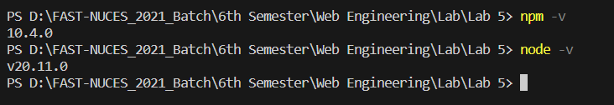

## Task 2: -

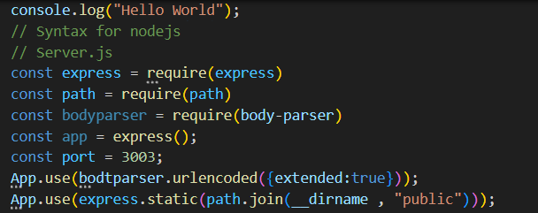

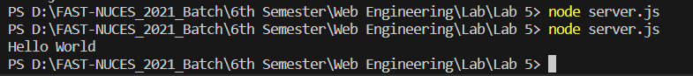

## Task 3: -

const express = require('express');

const app = express();

const port = 3001;

app.get('/', (req, res) => {

res.send('I am your server');

});

app.listen(port, () => {

console.log(`Server is running at [http://localhost:${port}`](http://localhost:$%7bport%7d%60));

});



## Task 4: -

const http = require('http');

const server = http.createServer((req, res) => {

const url = req.url;

if (url === '/success') {

res.writeHead(200, { 'Content-Type': 'text/plain' });

res.end('Success!');

} else if (url === '/notfound') {

res.writeHead(404, { 'Content-Type': 'text/plain' });

res.end('Not Found!');

} else if (url === '/internalerror') {

res.writeHead(500, { 'Content-Type': 'text/plain' });

res.end('Internal Server Error!');

} else if (url === '/badrequest') {

res.writeHead(400, { 'Content-Type': 'text/plain' });

res.end('Bad Request!');

} else {

res.writeHead(404, { 'Content-Type': 'text/plain' });

res.end('Not Found!');

}

});

const port = 3001;

server.listen(port, () => {

console.log(`Server is running at http://localhost:${port}`);

});

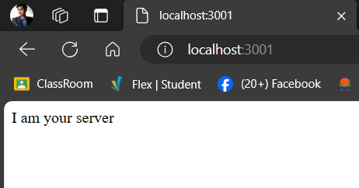

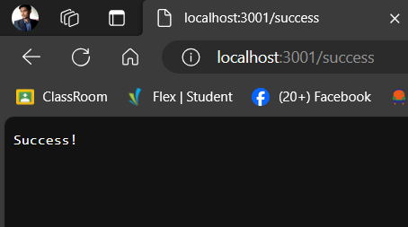

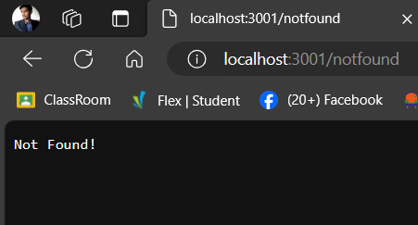

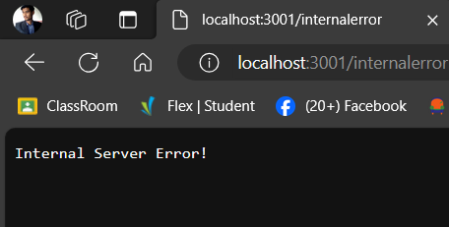

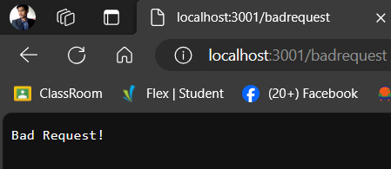

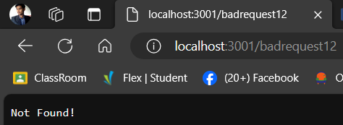

## Task 5: -

Temp.js: -

const myMessage = "Hello from myModule!";

function displayMessage() {

console.log(myMessage);

}

module.exports = {

displayMessage,

myMessage

};

Server.js: -

const http = require('http');

const myModule = require('./temp');

const server = http.createServer((req, res) => {

res.setHeader('Content-Type', 'text/plain');

myModule.displayMessage();

res.end(`Message from myModule: ${myModule.myMessage}\n`);

});

const PORT = 3061;

server.listen(PORT, () => {

console.log(`Server is listening on port ${PORT}`);

});

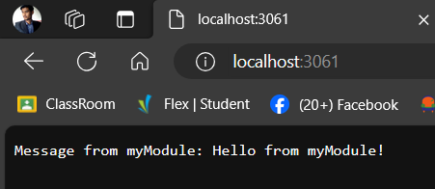



## Task 7: -

### Server.js: -

const http = require('http');

const karachi = require('./karachi');

const lahore = require('./lahore');

const islamabad = require('./islamabad');

const peshawar = require('./peshawar');

const multan = require('./multan');

const server = http.createServer((req, res) => {

res.setHeader('Content-Type', 'text/plain');

const messages = [

karachi.displayMessage(),

lahore.displayMessage(),

islamabad.displayMessage(),

peshawar.displayMessage(),

multan.displayMessage(),

].join('\n');

res.end(messages);

});

const PORT = 3001;

server.listen(PORT, () => {

console.log(`Server is listening on port ${PORT}`);

});

### Karachi.js: -

const cityName = 'Karachi';

let price = 10000;

let customer = 50;

const displayMessage = () => `-1-> Welcome to ${cityName} ==> Price ${price} , Custumer ${customer} ==>> Total Value {${price*customer}}`;

module.exports = {

cityName,

displayMessage,

};

### Islamabad: -

const cityName = 'Islamabad';

let price = 500;

let customer = 50;

const displayMessage = () => `-3-> Welcome to ${cityName} ==> Price ${price} , Custumer ${customer} ==>> Value {${price*customer}}`;

module.exports = {

cityName,

displayMessage,

};

### Lahore: -

const cityName = 'Lahore';

let price = 5000;

let customer = 25;

const displayMessage = () => `-2-> Welcome to ${cityName} ==> Price ${price} , Custumer ${customer} ==>> Value {${price*customer}}`;

module.exports = {

cityName,

displayMessage,

};

### Multan: -

const cityName = 'Multan';

let price = 50;

let customer = 67;

const displayMessage = () => `-5-> Welcome to ${cityName} ==> Price ${price} , Custumer ${customer} ==>> Value {${price*customer}}`;

module.exports = {

cityName,

displayMessage,

};

### Peshawar: -

const cityName = 'Peshawar';

let price = 600;

let customer = 30;

const displayMessage = () => `-4-> Welcome to ${cityName} ==> Price ${price} , Custumer ${customer} ==>> Value {${price*customer}}`;

module.exports = {

cityName,

displayMessage,

};

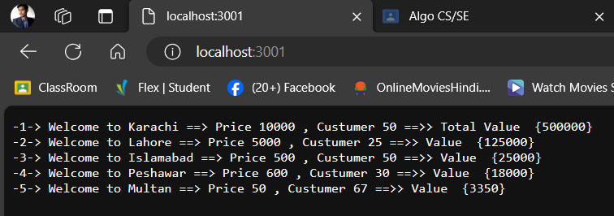



## Task 8: -

### Server.js:

const http = require('http');

const karachi = require('./karachi');

const lahore = require('./lahore');

const islamabad = require('./islamabad');

const multan = require('./multan');

const server = http.createServer((req, res) => {

  res.setHeader('Content-Type', 'text/plain');

  const messages = [

    karachi.displayMessage(),

    lahore.displayMessage(),

    islamabad.displayMessage(),

    multan.displayMessage(),

  ].join('\n');

  res.end(messages);

});

const PORT = 3001;

server.listen(PORT, () => {

  console.log(`Server is listening on port ${PORT}`);

});

### Islamabad:

let x = 10;

let y = 5;

const displayMessage = () => `-3-> X-Value {${x}} , Y-Value {${y}} ==>> Addition {${x+y}}`;

module.exports = {

  displayMessage,

};

### Karachi:

let x = 10;

let y = 5;

const displayMessage = () => `-1-> X-Value {${x}} , Y-Value {${y}} ==>> Substraction {${x-y}}`;

module.exports = {

  displayMessage,

};

### Lahore:

let x = 10;

let y = 5;

const displayMessage = () => `-2-> X-Value {${x}} , Y-Value {${y}} ==>> Multiplication {${x*y}}`;

module.exports = {

  displayMessage,

};

### Multan:

let x = 10;

let y = 5;

const displayMessage = () => `-5-> X-Value {${x}} , Y-Value {${y}} ==>> Divide {${x/y}}`;

module.exports = {

  displayMessage,

};

